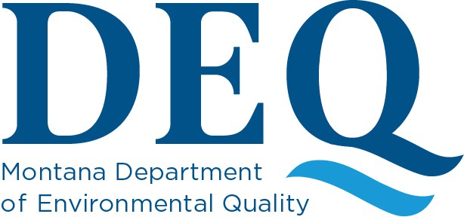

December 14, 2021

Re: Fiberglass insulation as a suspect material for Asbestos Inspection purposes. Dear Interested Persons:
The intent of this notice is to clarify the Montana Department of Environmental Quality (DEQ) Asbestos Control Program (ACP) position on the sampling of fiberglass insulation information for fulfilling Asbestos inspection requirements.

- EPA requires a thorough inspection prior to demolition or renovation activity at a regulated structure.

- Montana ACA grants rulemaking authority to DEQ for the fulfillment of inspection requirement. See MCA 75-2-503(f)

- ACP, through rulemaking, has established criteria on who may sample, how they must sample, how analytical results are achieved, and contents for reports.

- EPA has provided direction that Fiberglass does not meet the definition of “glass” from Applicability Determination A960025

It is the position of ACP that those parties who develop, review, accept, or acknowledge asbestos inspection reports, be directed to base their suspect materials on the term “thoroughly inspect”, on current Administrative Rule requirements, and on the EPAs October 2021 response.
EPA has evaluated the applicability of Fiberglass as a suspect material and, in an October 2021 letter, found that fiberglass should not be excluded as a suspect material.

The Asbestos Control Program appreciates your consideration in this matter and welcomes any questions, comments, or concerns you may have.

Sincerely,

The Asbestos Control Program 406-444-5300
deqacponline@mt.gov

